Canon Image RUNNER 7200 Specifications

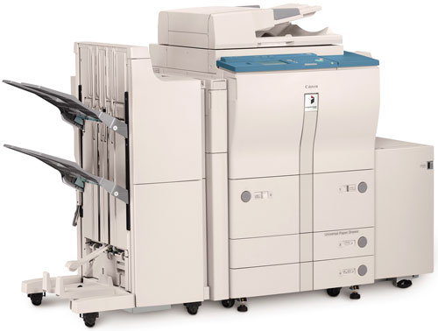

Main Unit
Type : Digital, Multifunction Imaging System
Imaging System : Laser Dry Electrostatic Transfer
Developing System : Dry Monocomponent ToneProjection
Image Server Memory : Standard 192MB RAM + 10GBHDD
First-copy Time : 3.1 Seconds from Platen Glass
4.3 Seconds from ADF
Warm-up Time : 6 Minutes or Less
Acceptable Originals : Sheets, Books, 3-dimensional Items
Max. Original Size : 11" x 17" (Ledger)
Max. Copy Size : 11" x 17" (Ledger)
Min. Copy Size : 4-1/8" x 5-7/8"
Max. Copy Reservation : 5 Jobs
Copy/Scanning Resolution : 600 dpi x 600 dpi
1200 dpi x 600 dpi Interpolated
Printing Resolution : 600 dpi x 600 dpi
2400 dpi x 600 dpi Interpolated
Halftone : 256 Gradations of Gray
Copy Speed : 72 cpm (Letter)
36 cpm (Ledger)
Duplexing : Standard Automatic Trayless

Magnification Reduction
Enlargement : 25% to 400% in 1% Increments
Paper Suppy
Standard : Dual Front-loading Trays
(1,500 Sheets Each)
Dual Front-loading Cassettes
(550 Sheets Each)
50-sheet Stack Bypass
Optional : 3,500-sheet Paper Deck-M1
(Total: 7,650 Sheets)
Multiple Copies : 1 to 9,999
Paper Weights : 17 lb. Bond to 110 lb. Index (All Paper Sources)
Mail Box : 100 (7,700 Pages/Letter)
Dept. ID : 1,000 (7-digit IDs and Passwords)

Supplies
Drum : Amorphous Silicon – Estimated Yield : 5,000,000 Impressions
Maximum Duty Cycle : 350,000 Impressions per Month
Toner : Magnetic Positive Toner –
Estimated Yield : 33,000 Images
ACCESSORIES

We are the canon Rc1 Dealers in Bangalore contact: canonrc1bangalore@gmail.com 9060002096 .9945457636.9880988731

